# What is k8s?

Its a open source container orchestration tool

Help manage container (If we have huge number of containers its hard to manage it)

# Features it provide

1) High Availability or no down time

2) Scalability and high performance

3) Disaster recovery

# Components of Kubernetes

***Node:-*** simple server /worker node physical or virtual

***Pod:-***smallest unit in k8s ,its abstraction over container

How it communicate within :- it offers its virtual network so each pod gets its own **ip address**

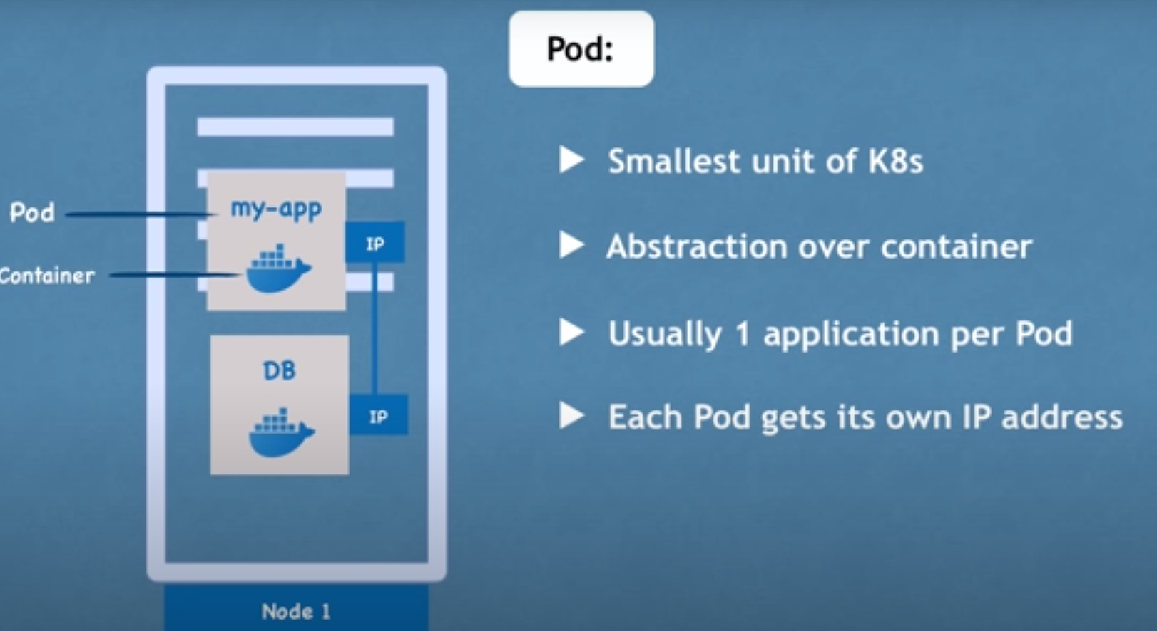

So pod can die very easily and if it happens we loose ip associated with it and when new pod spans in place of that

That will have a new ip ,but if we had communicated with previous ip ,we need to synk this new ip so for that a

New component we have is ***service***

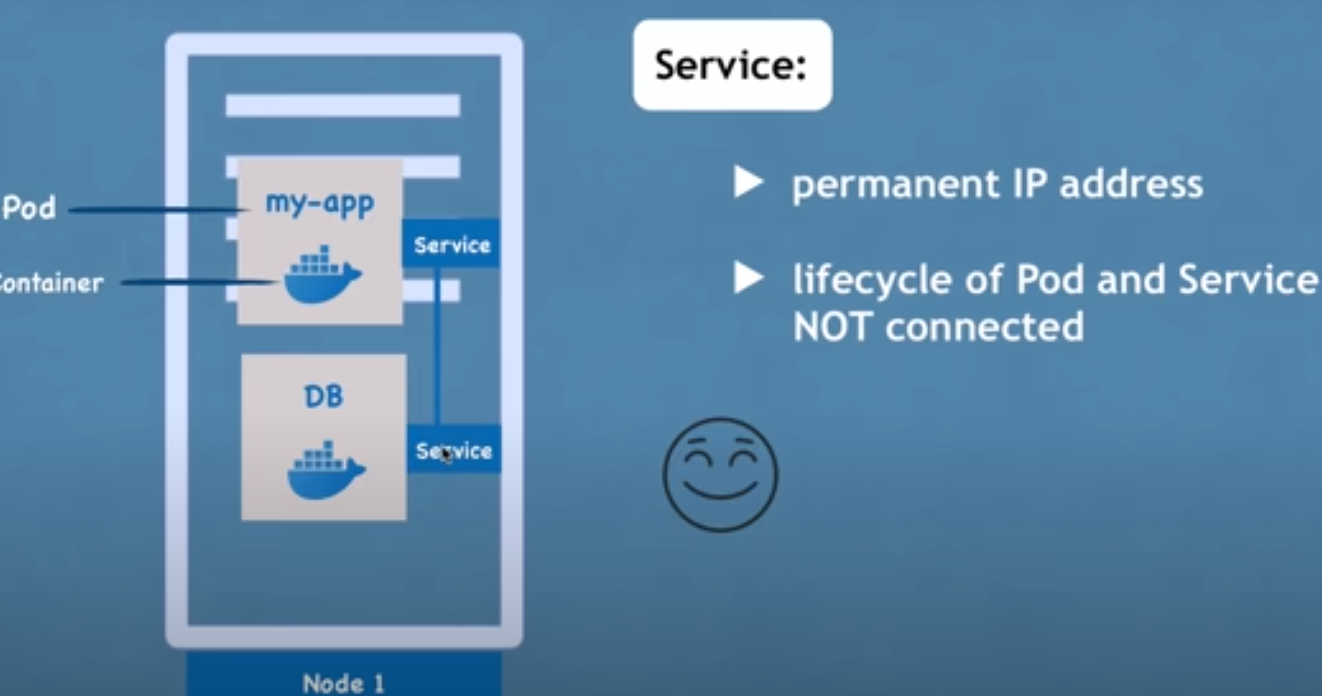

All these components were internal all Ip and all but we need to make our app available externally ,so for this we need to create a external service

And we need DNS kind of mapping for external url (http://124 .2) we don’t need this so to map this we have another component call ingress

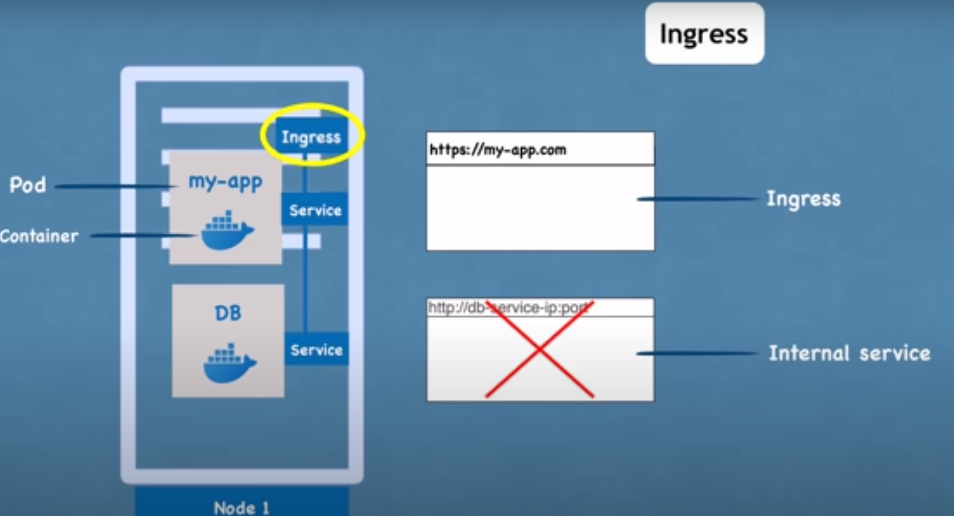

So first request go to **ingress** then to service here for app we have external service and for db we have internal

***ConfigMap*** and ***secrets*** :-config map contains url of db and other configurations

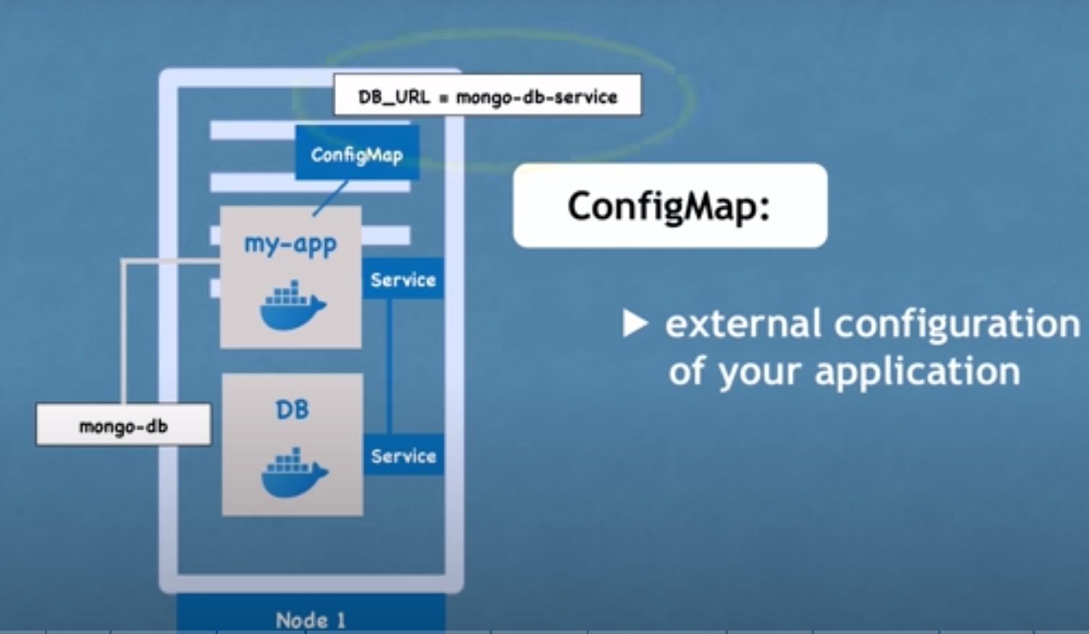 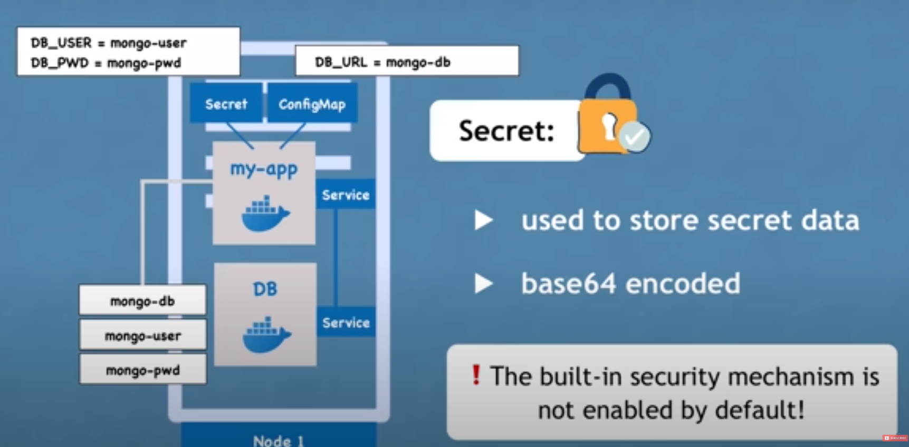

And user name and passwords are put in secret its just like config map but it stores encrypted details

***Volumes*** :- if pod restarted let say db its data will be lost so we have volumes for that ,it attaches a physical storage to your pod

If node 1 app dies we have replication connected to service

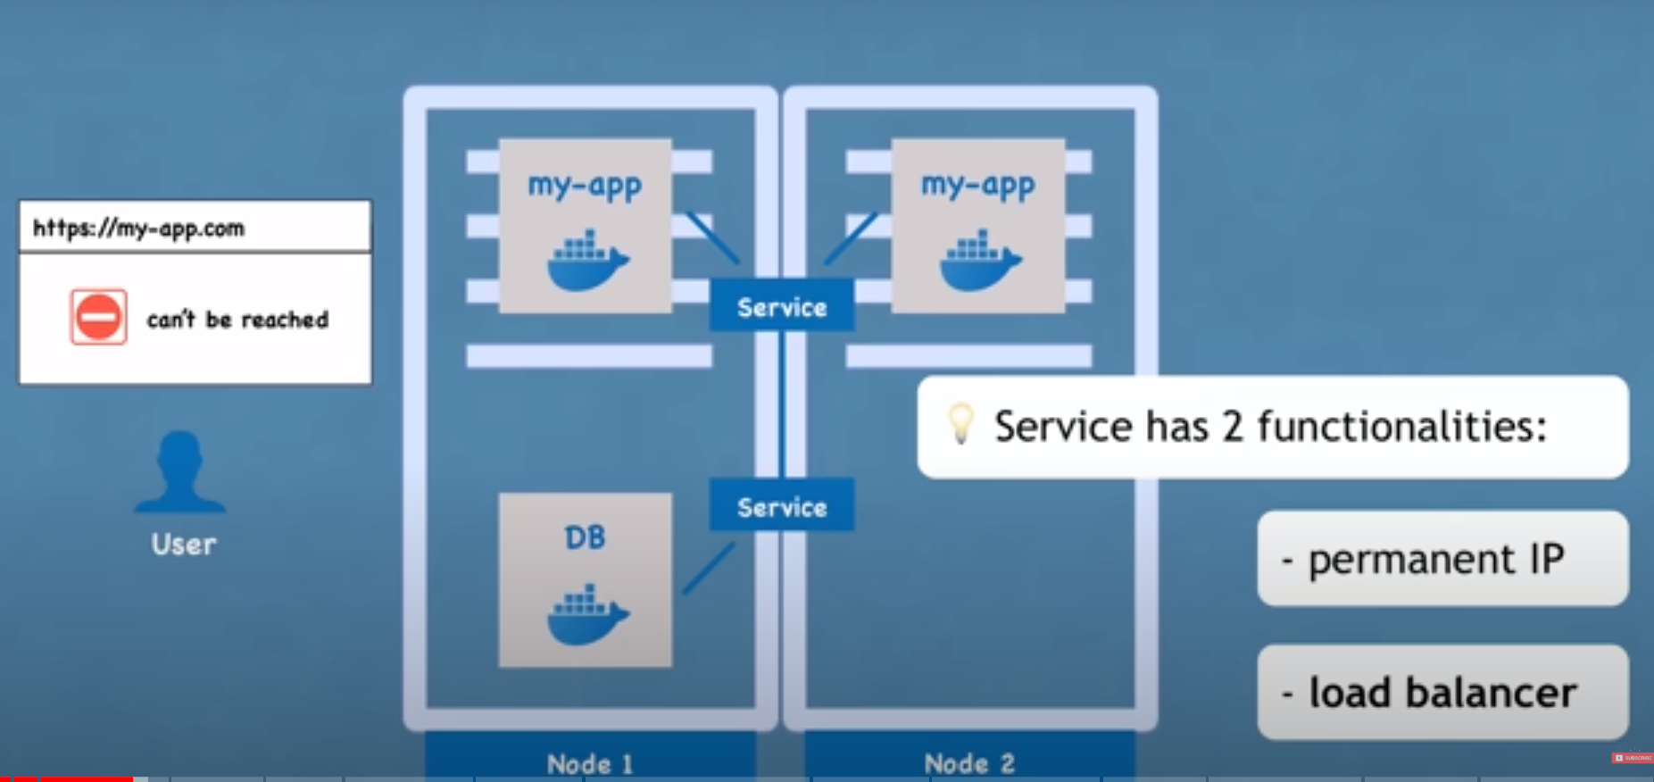

We define a blue print for pod and add replication in it so this is another component called ***deployment*** to do that

Basically we don’t create pods directly we create deployment with pod specification and replicas in it.

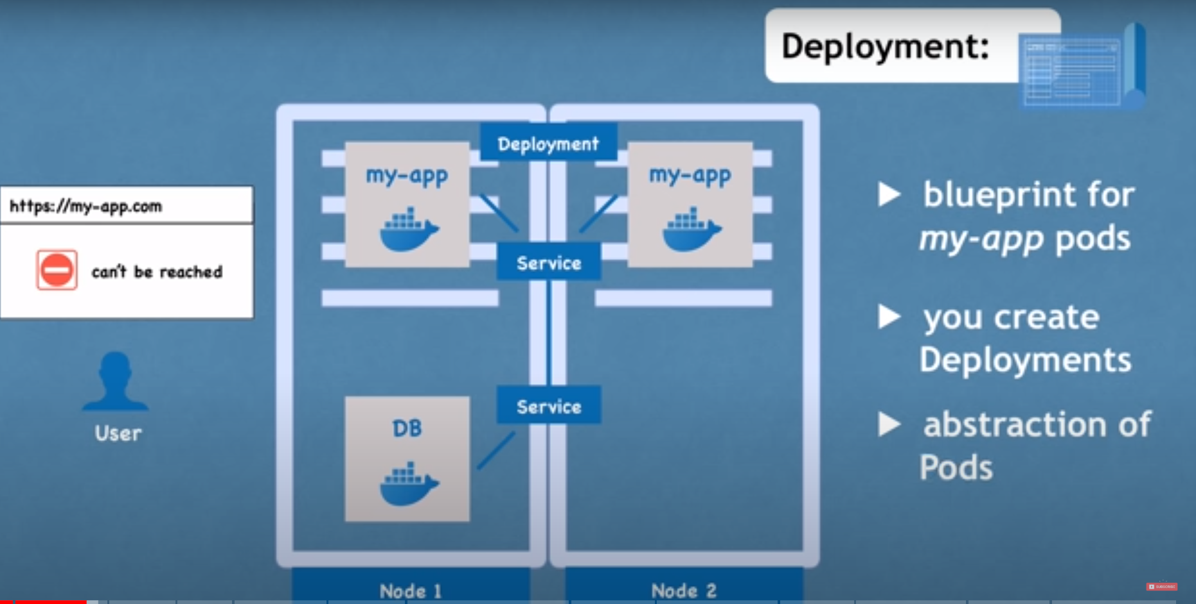

We can have db replication also with deployment because we need shared data among all db pods (it should be consistent) or synced so to do that we have another component called ***statefulSet*** for that.

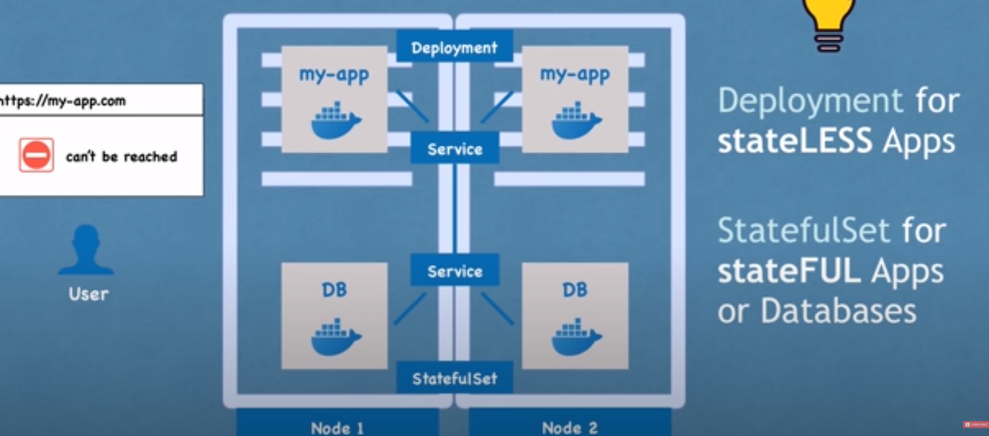

# Basic architecture of k8s:-

3 process need to be installed on every node inorder for k8s to function

1. Container runtime (docker or other)
2. Kubelet :-interact with container runtime and node (It starts the pods with container inside)
3. Kube proxy :- forwards request from services to pods

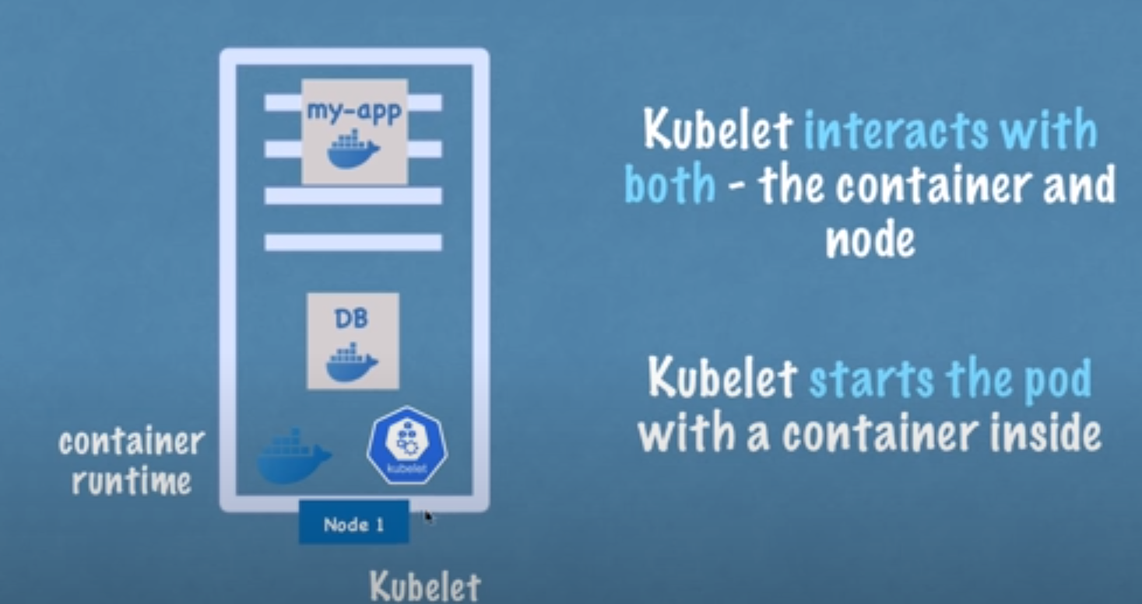 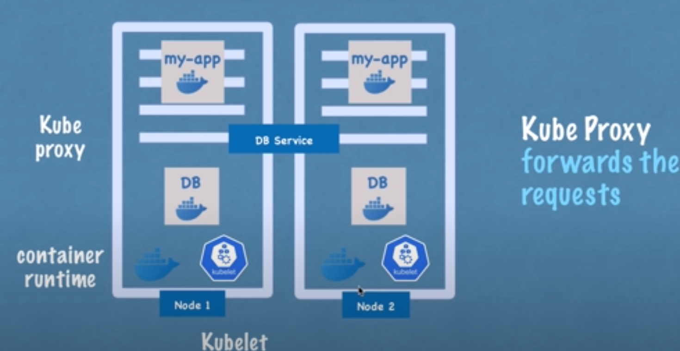

Master Node :- does all managing /monitoring cluster stuff ,if node dies replicate it

In this node 4 process were installed , api server (cluster gateway) 27 min

1. api server:- if new app needs a deploy in k8s then we need to intact with api server ,Authenticate request

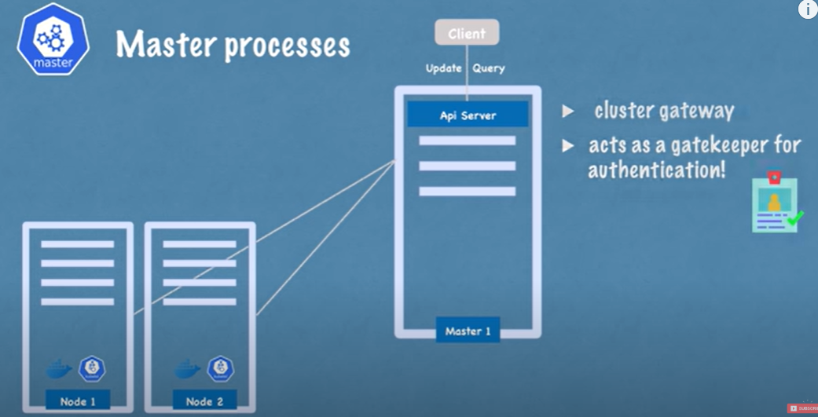 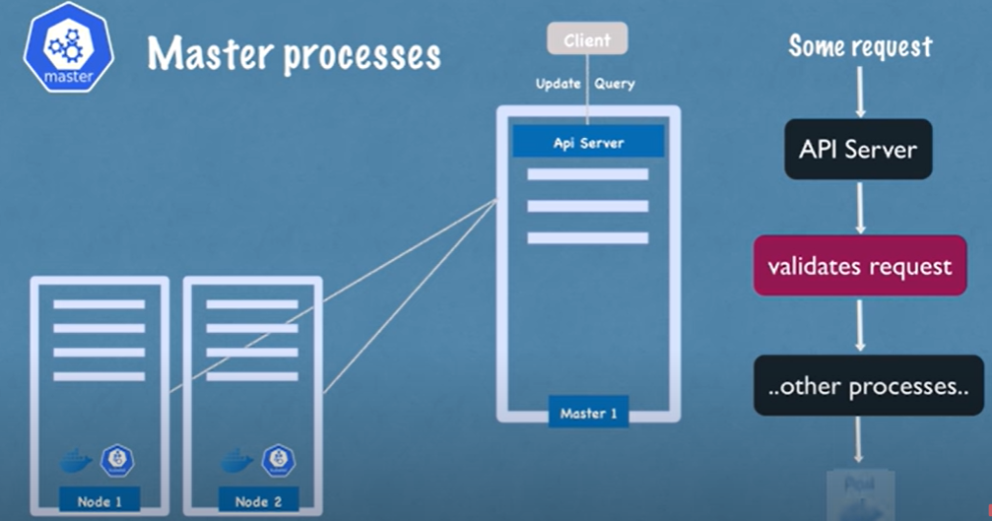

1. Scheduler:- Api server hands the request after validation to scheduler to start a pod

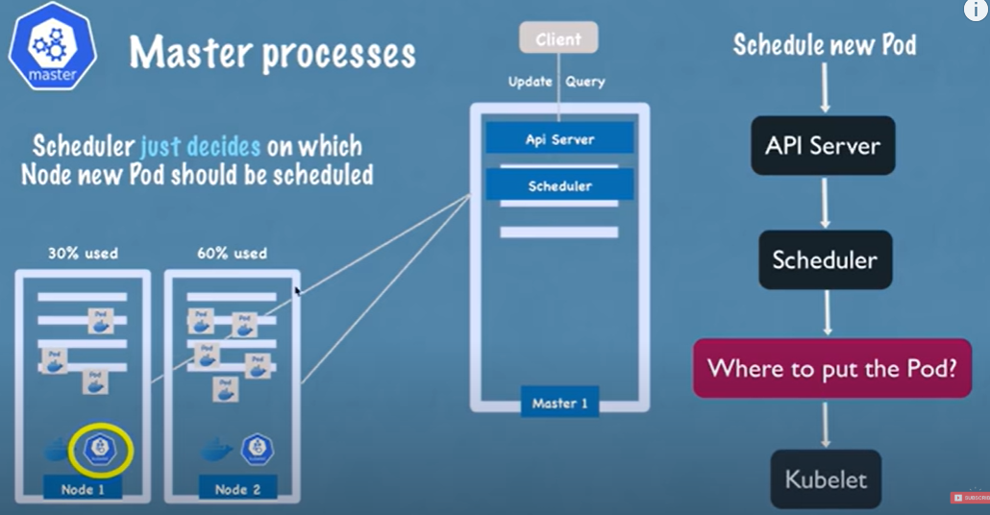

1. Controller manager :- if pod dies on any node there must be a way to detect and reschedule back that pod ,so it detects it and try to recover and send request to scheduler to schedule another if dies

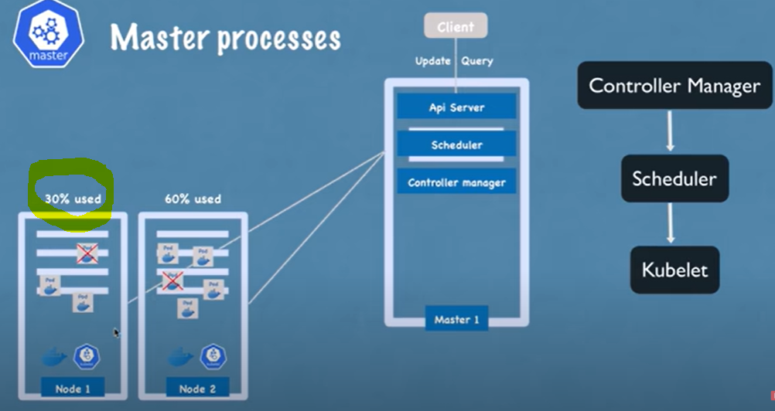

1. Etcd :- it is a cluster brain , a key value store ,all data is stored in this ,if pod dies this data is stored here and other process get a communication from this process only

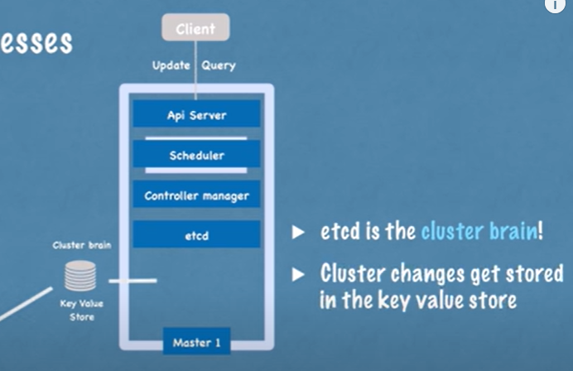

33 min Done

In production you have multiple node

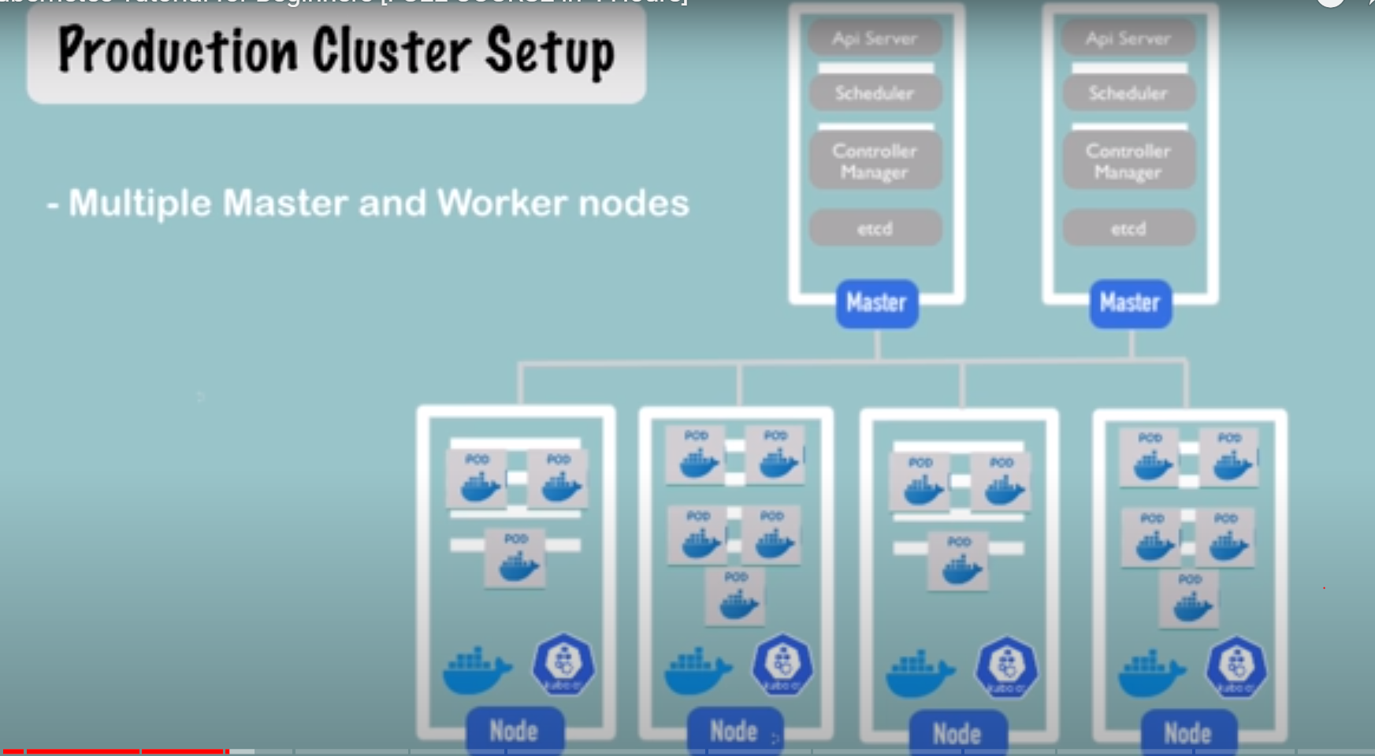

For Dev/Test you need something like this on your machine so minikube is there ,it’s a one node cluster

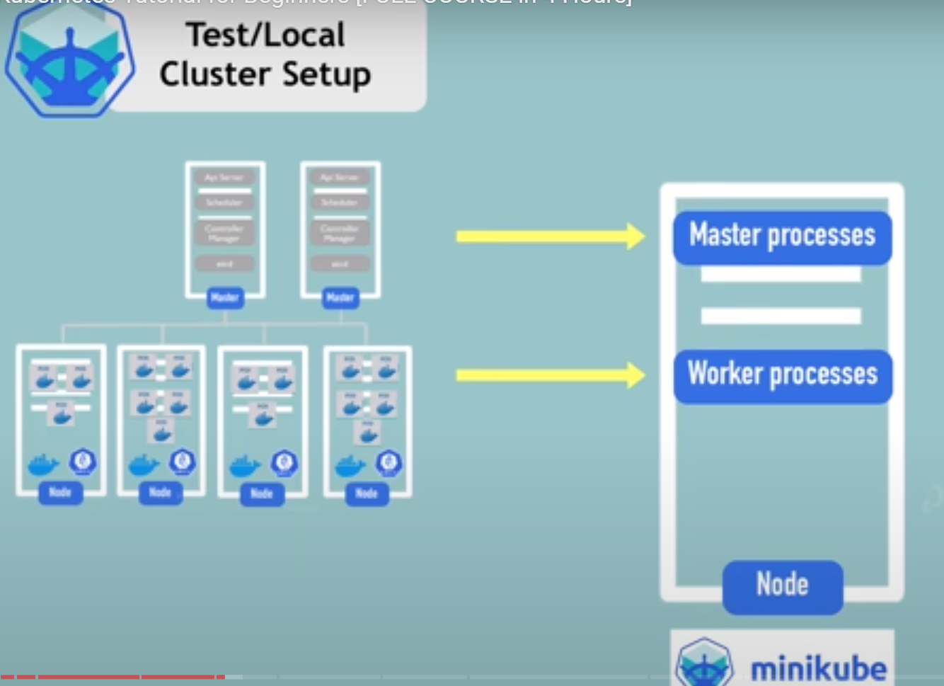

We can interact with k8s cluster with kubectl via api server

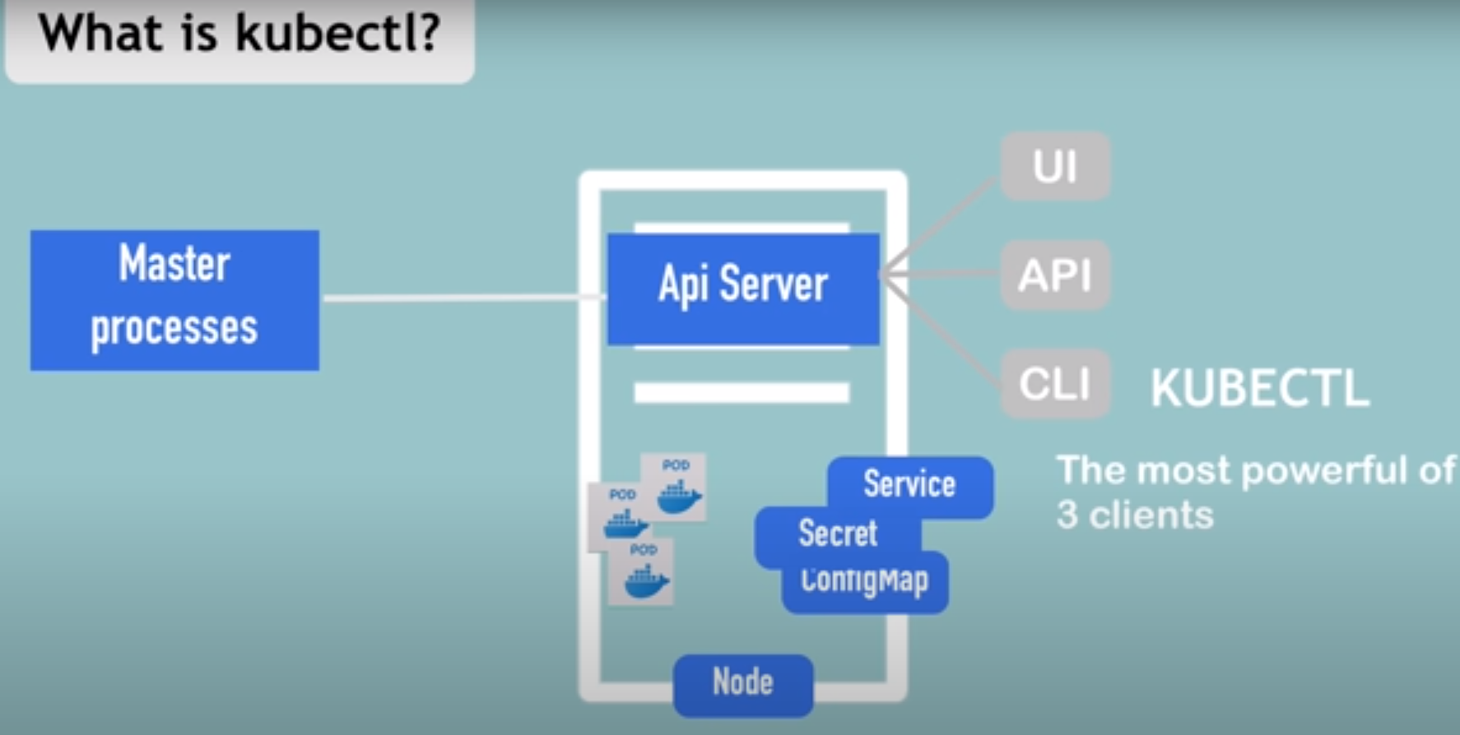

Minikube installation 39m ,minikube will also install kubctl internally as it had dependency over it

Command :-

### create minikube cluster

minikube start --vm-driver=hyperkit

kubectl get nodes

minikube status

kubectl version

### delete cluster and restart in debug mode

minikube delete

minikube start --vm-driver=hyperkit --v=7 --alsologtostderr

minikube status

### kubectl commands

kubectl get nodes

kubectl get pod (list all available pods)

kubectl get services

kubectl create deployment nginx-depl --image=nginx (deployment is abtraction on pod so this will create a pod of nginx image ,pod need some image to be created)

kubectl get deployment

kubectl get replicaset (replica set will manage all replica of pod automatically )

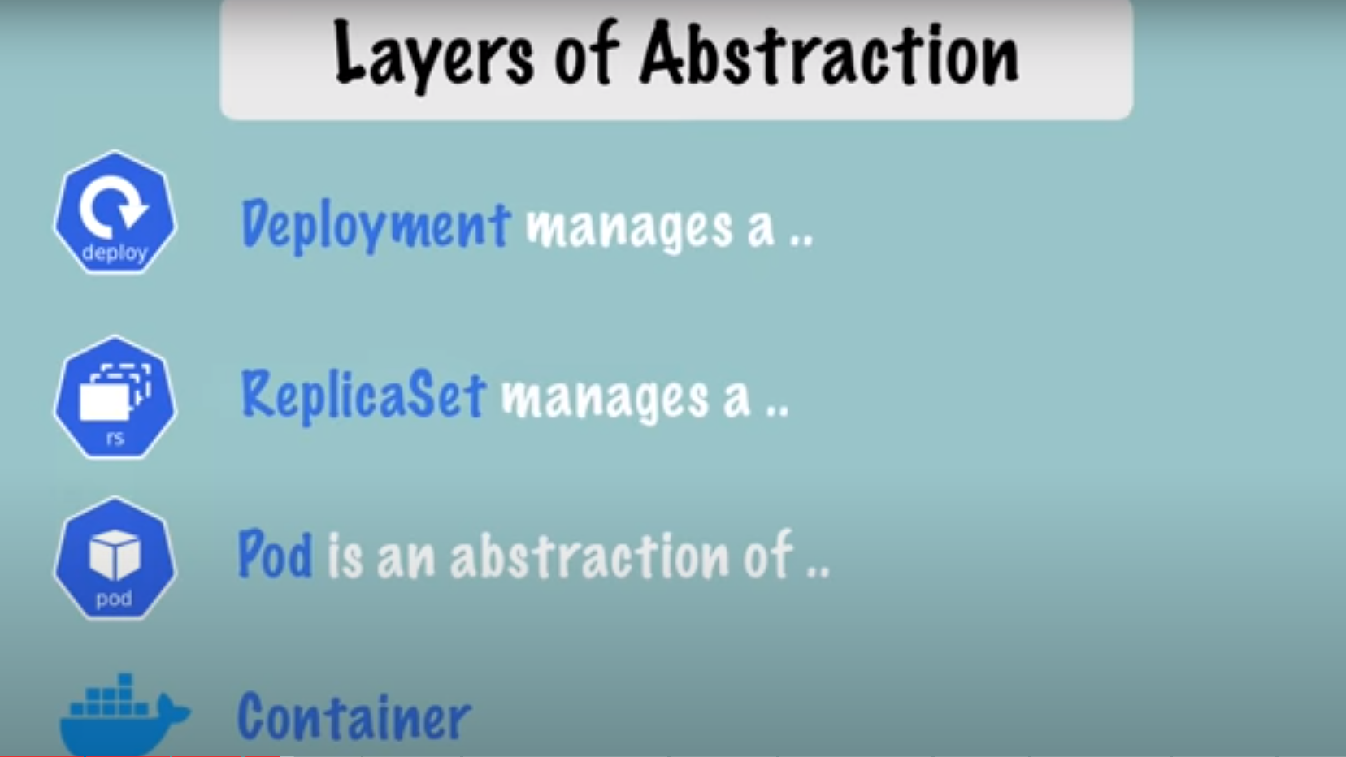

kubectl edit deployment nginx-depl

### debugging

kubectl logs {pod-name}

kubectl exec -it {pod-name} -- bin/bash (open a terminal )

### create mongo deployment

kubectl create deployment mongo-depl --image=mongo

kubectl logs mongo-depl-{pod-name}

kubectl describe pod mongo-depl-{pod-name}

### delete deplyoment

kubectl delete deployment mongo-depl

kubectl delete deployment nginx-depl

**!! ALL CRUD OPERATIONS HAPPENS AT DEPLOYMENT LEVEL !!**

### create or edit config file

vim nginx-deployment.yaml

kubectl apply -f nginx-deployment.yaml (To execute created deployment file)

kubectl get pod

kubectl get deployment

### delete with config

kubectl delete -f nginx-deployment.yaml

#Metrics

kubectl top The kubectl top command returns current CPU and memory usage for a cluster’s pods or nodes, or for a particular pod or node if specified.

1hr

# Yaml configuration File in K8s

Main tool for creating configuring components in k8s

Every conf file had below 3 parts to it metadata,specification,status (status will be auto generated and added by kubernetes ,so k8s will compare whats is disired state and actual state of that component if both does not match let say replica then k8s will try to fix it )

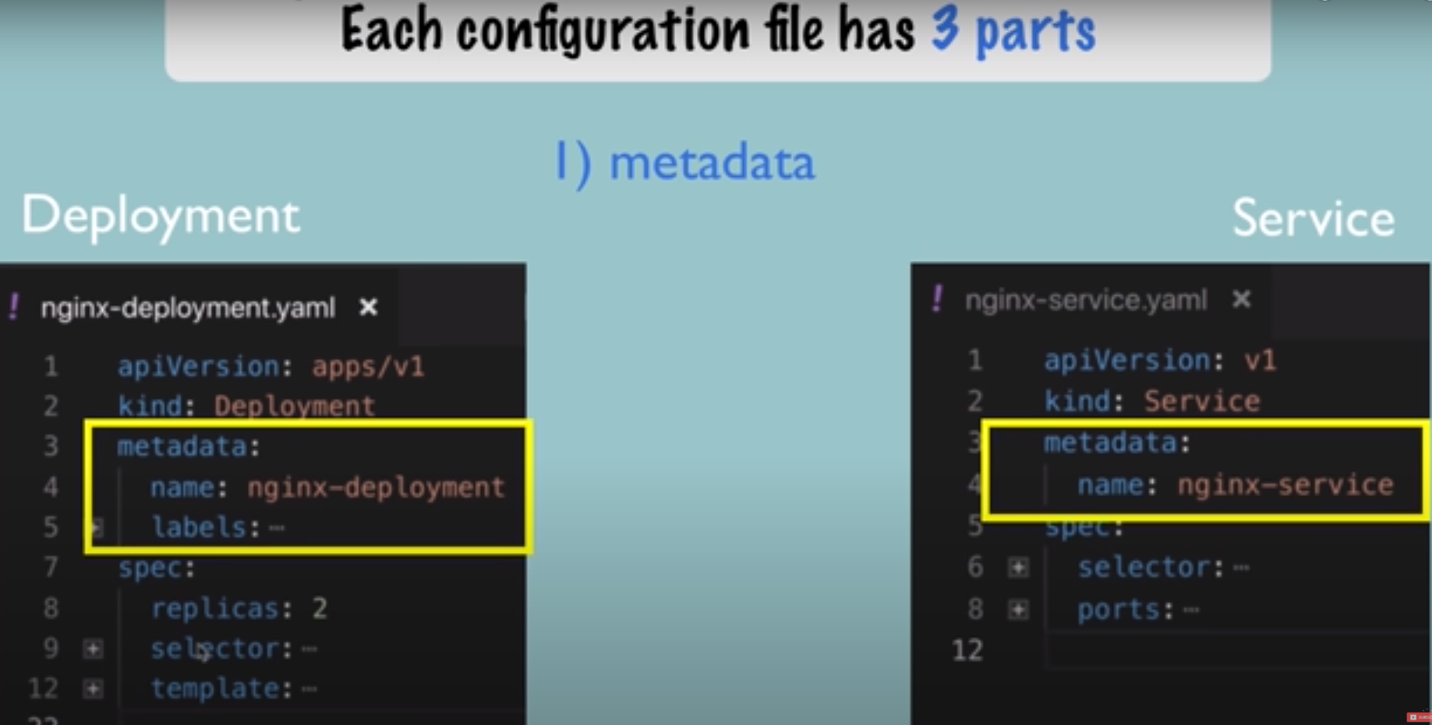

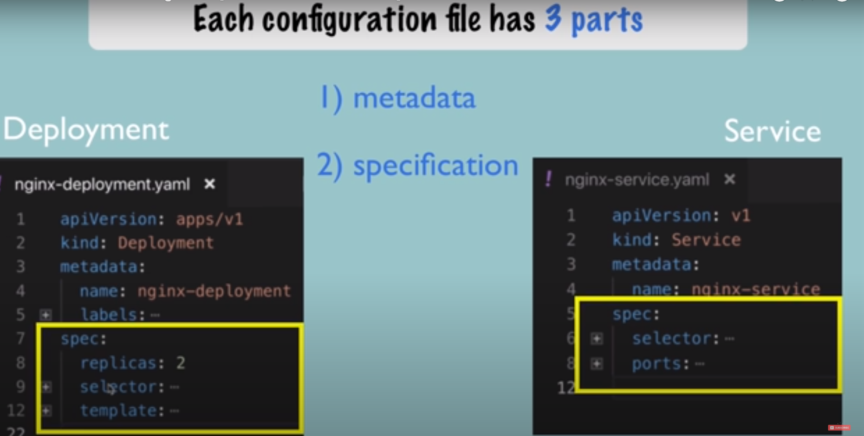

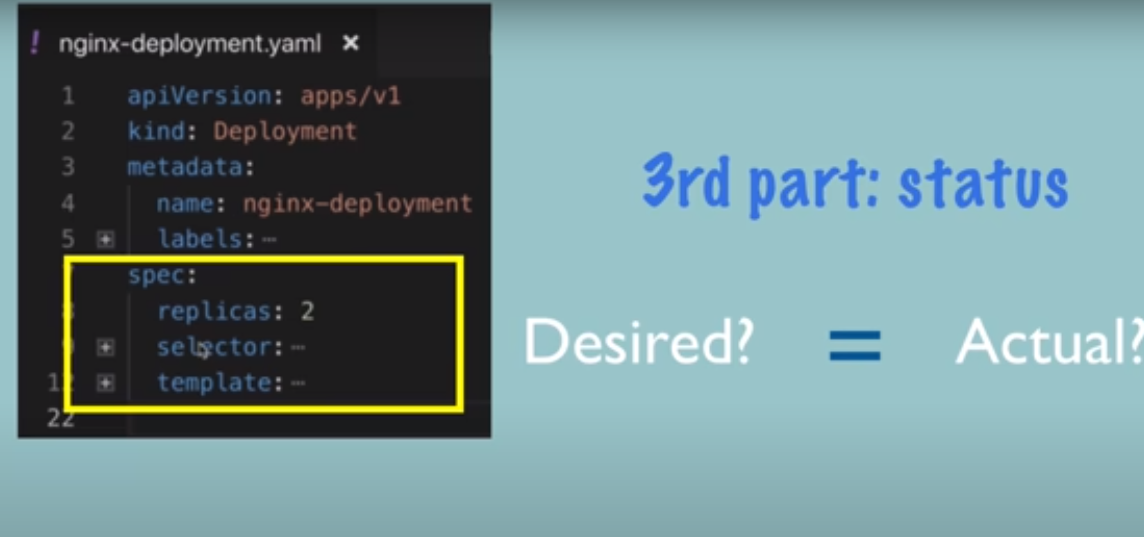

If desired and actual is not equal then it tried to fix some thing ,so self healing

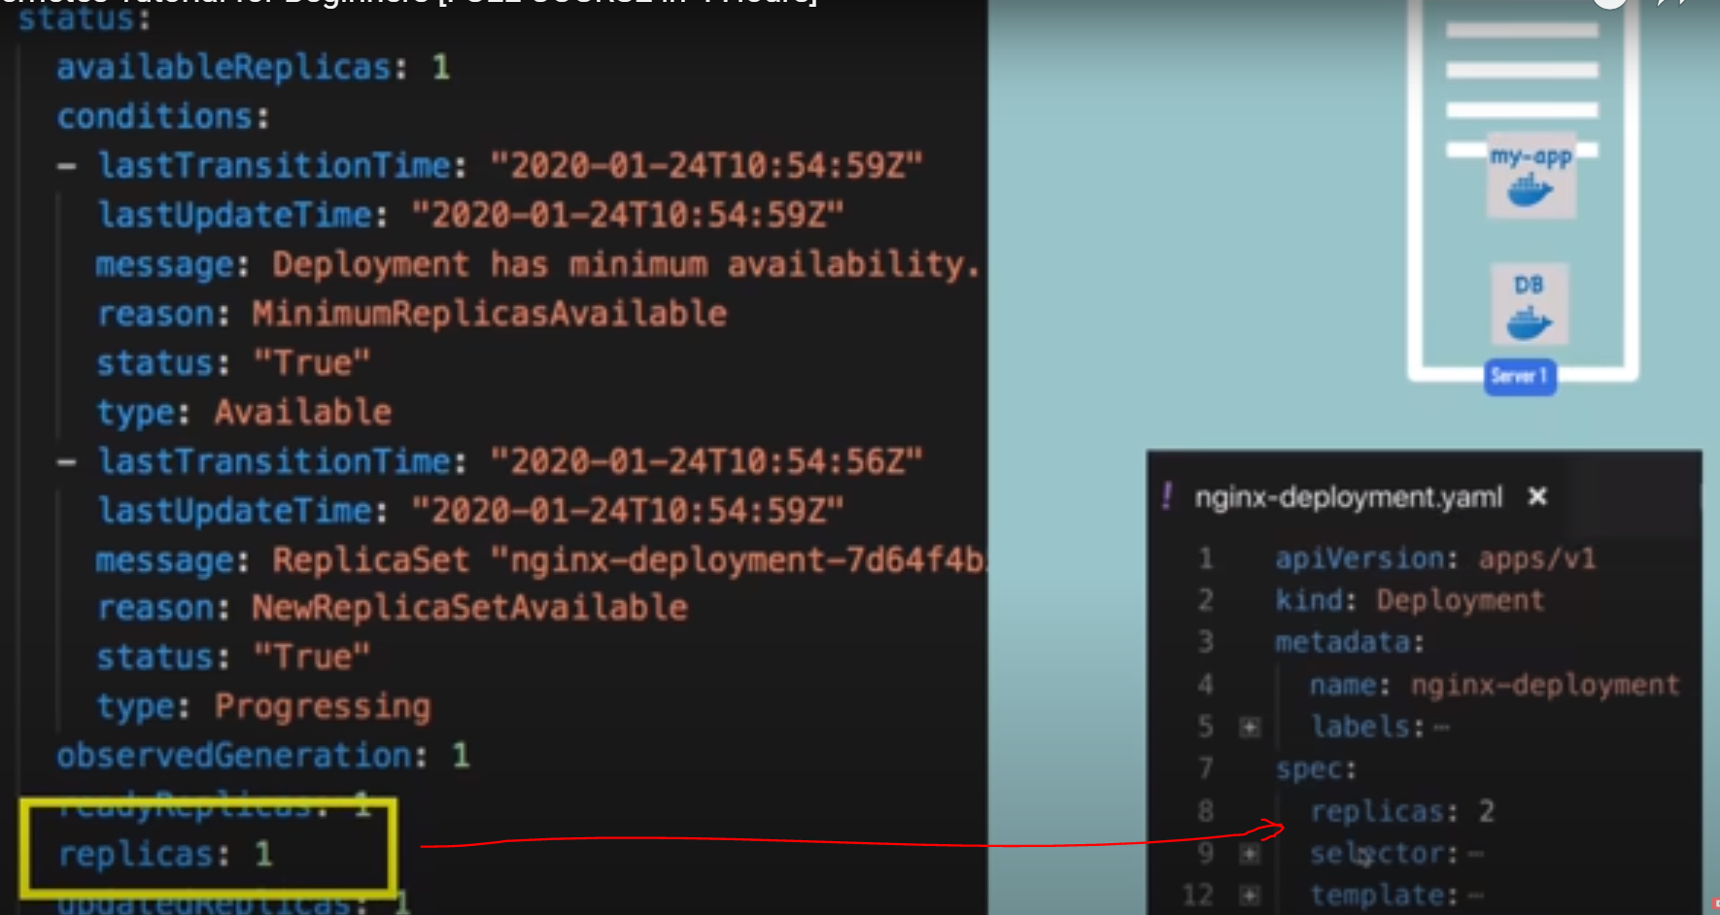

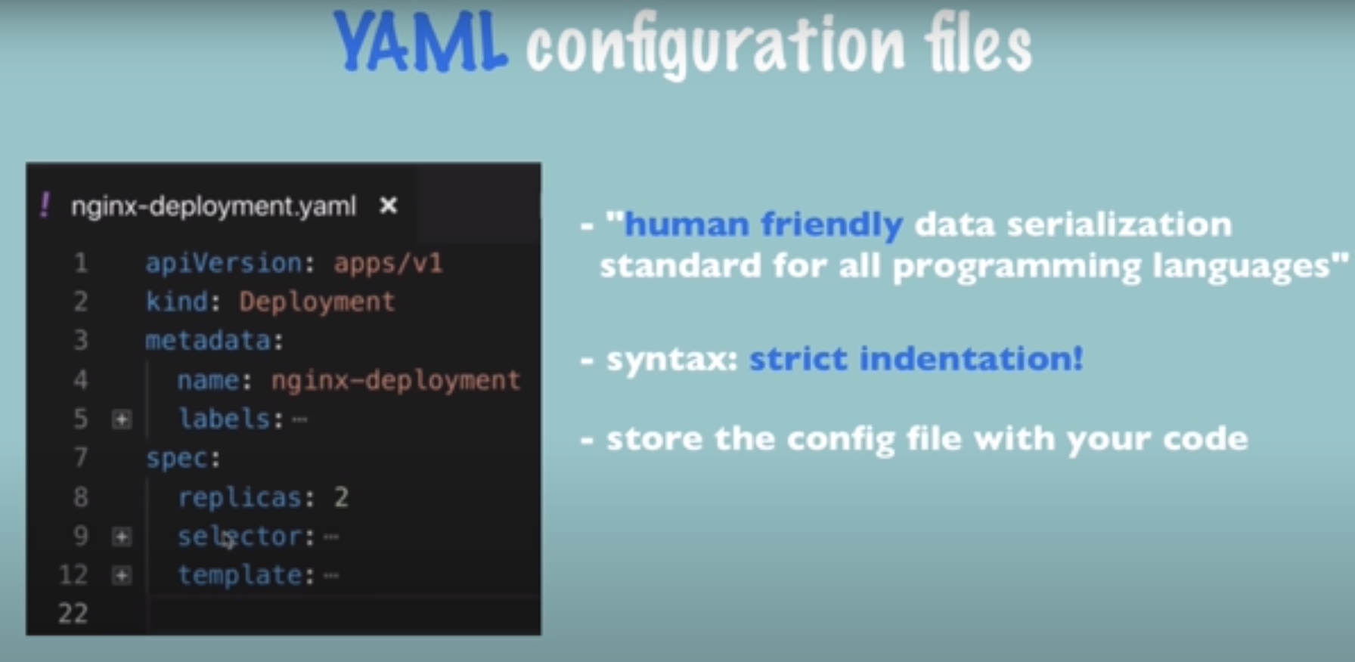 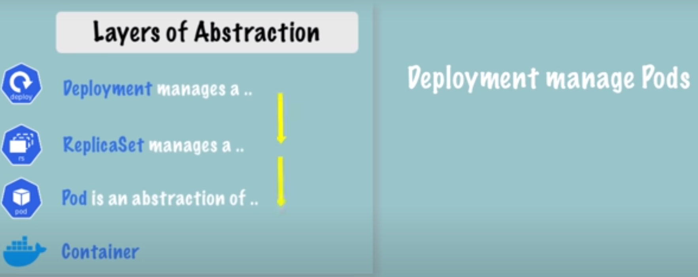

Deployemnt manages pods below it

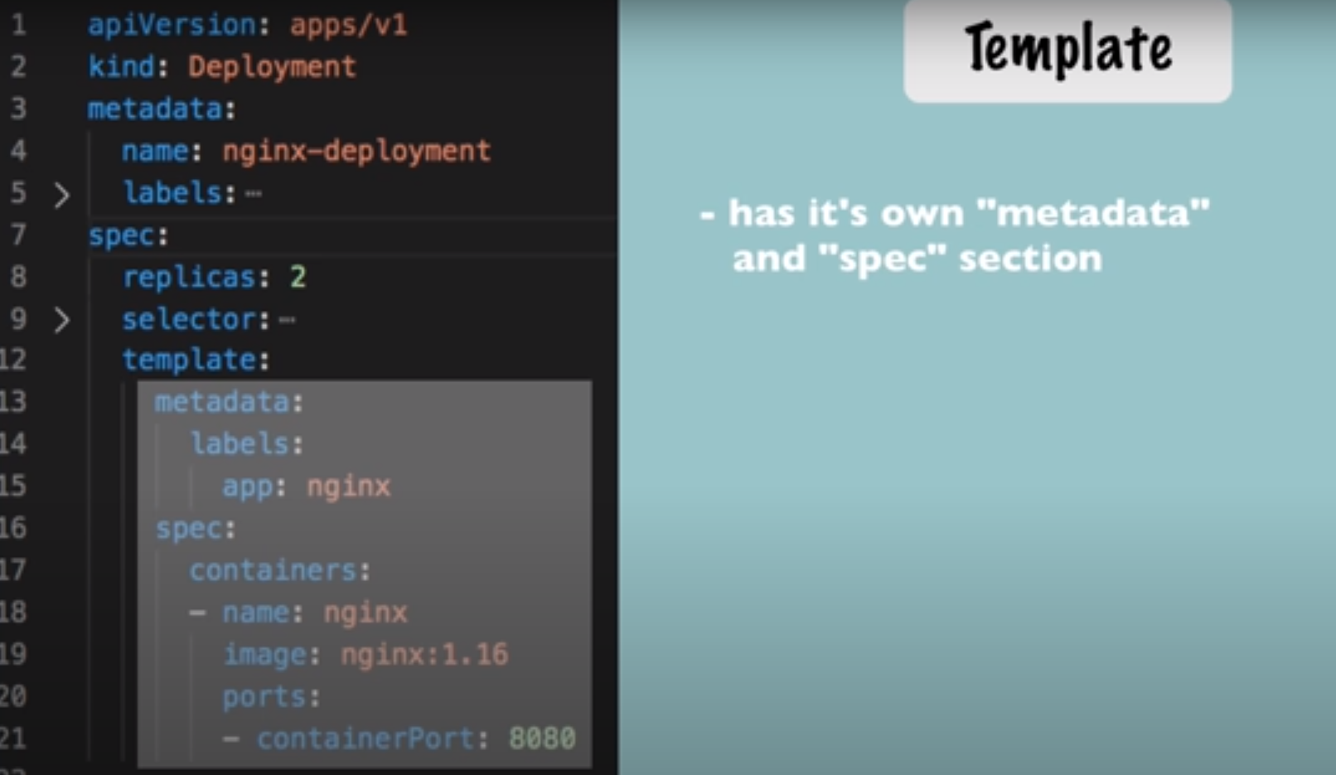

This inner configuration is applied to Pod (highlighted above)and this will be a blue print for a pod

Like which image its based on which port ,name of the container

*Connection is stablished using labels and selectors (between pod-deployment and deployment-service connections)*

Labels are in metadata section and selectors are in spec

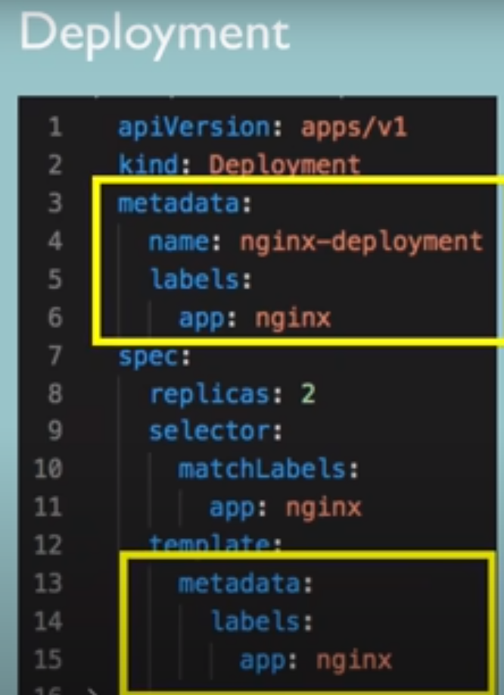 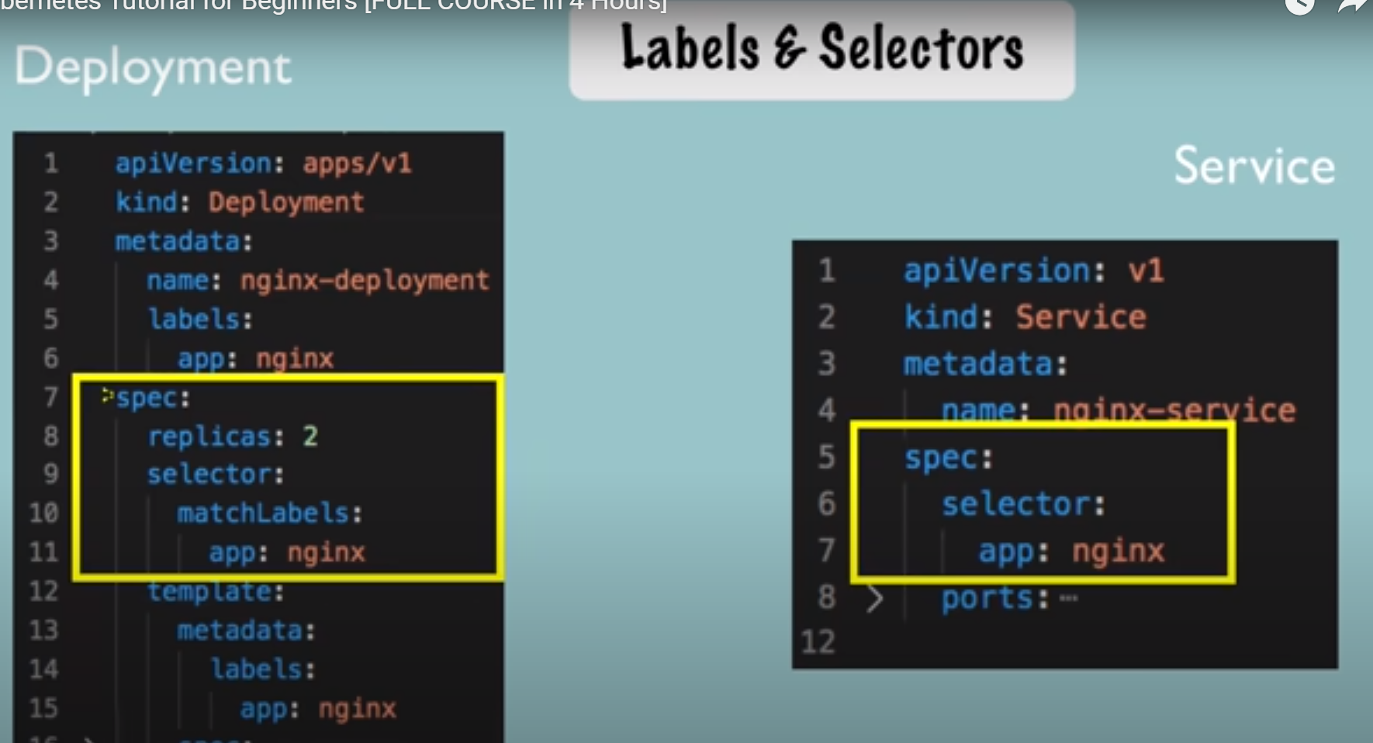

Connecting deployment to pod :- any key pair for component in this case **app:nginx** ,that label sticks to that component and this lable is matched by selector

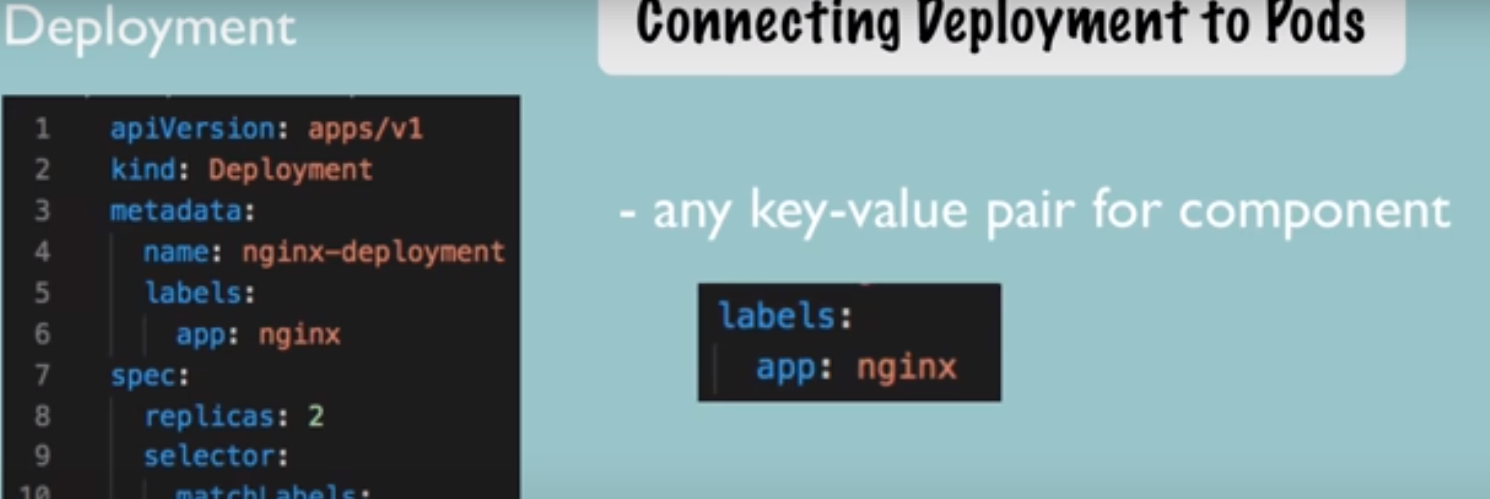

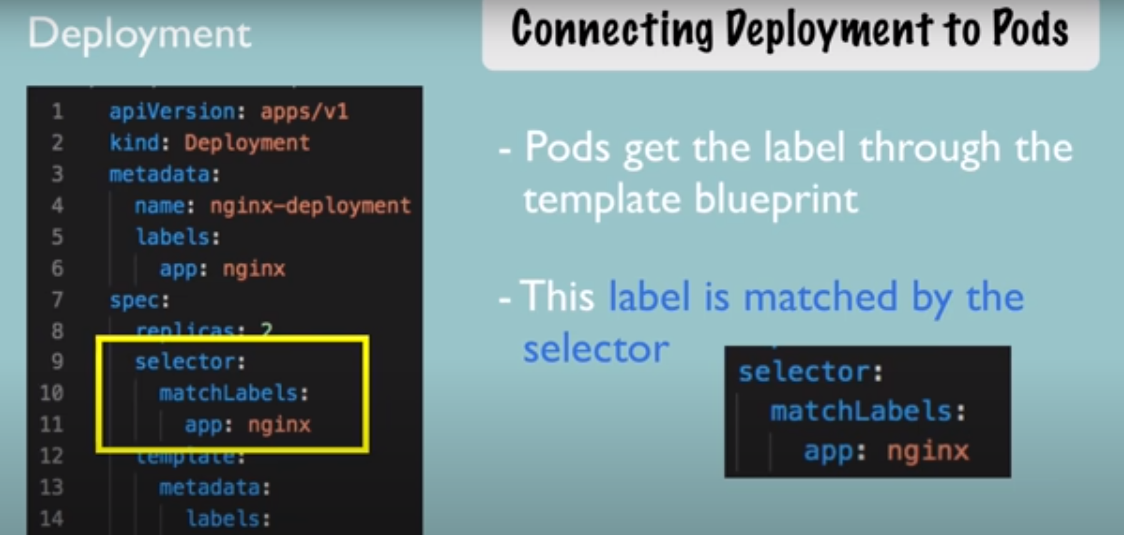

So this way deployment will know which pod belongs to it now connecting service to deployment and pod

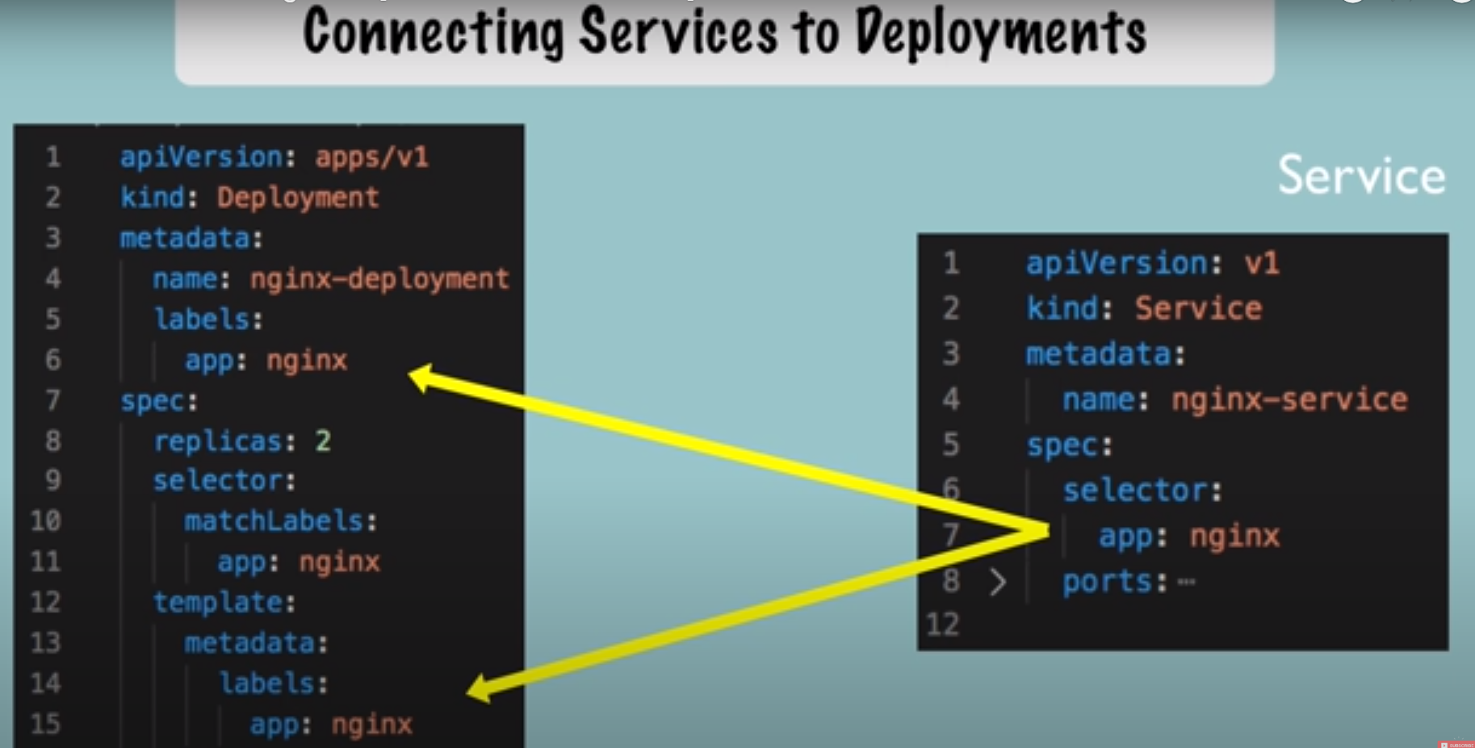

Another thing must be configured in service and pod is ports

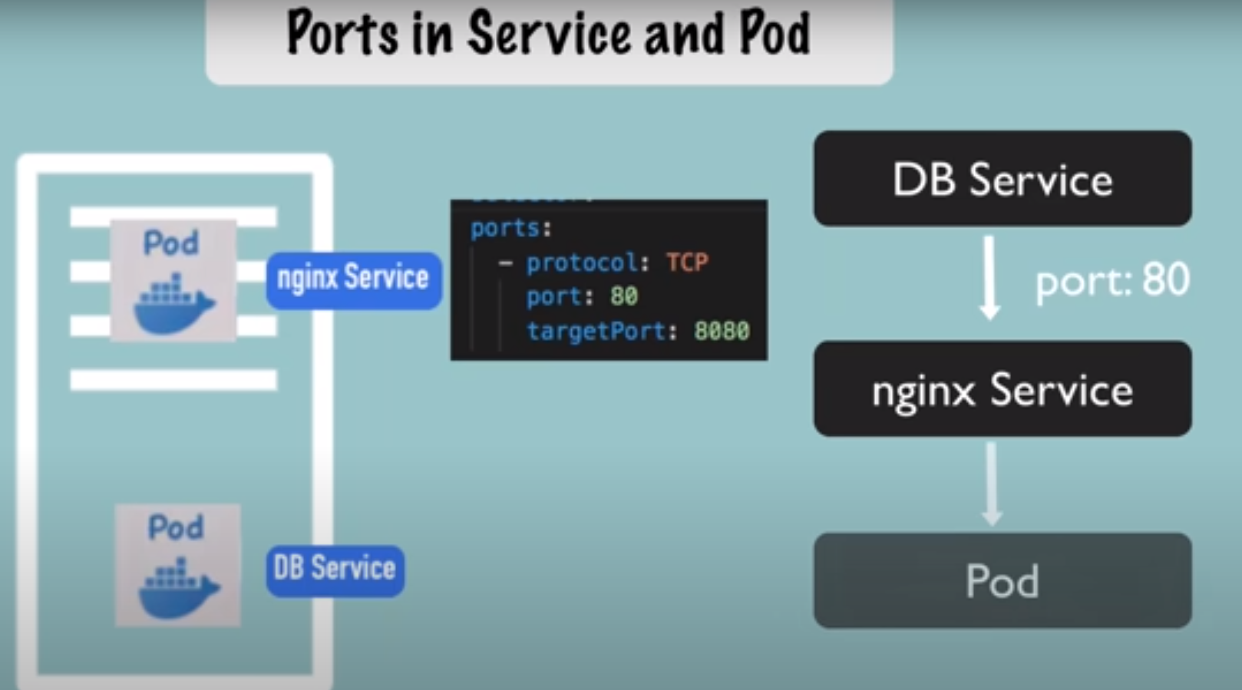

So service is listning to port 80 and now service whats to send request to pod so

That is defined in targetport and it should match to containerPort inside pod conf

